**Capital Improvement Projects 2025- 2029**

|  |  |
| --- | --- |
| **Project Name:**  **Downtown Streetscape North – Phase III (Bridge Street)** | **Department:**  **Public Works** |
| **Type of Project:**  **Improvement** | **Contact**:  **Charles Soules** |
| **Total Project Cost:**  **$1.500,000** | |

**Description:**

This project will continue the multi-year process of constructing downtown streetscape improvements, including further pedestrian and bicycle improvements, with the 3rd phase of streetscape extending on Bridge Street from Church Street to 1st Street. The project will include a mill and overlay of the pavement, full sidewalk replacement, installation of crosswalk, signs, pedestrian lighting, brick accents, storm water improvements, decorative rail on bridge, bike arrows and “Share the Road” signage.

*“Before and After” Design Plans*

**“***Before and After” Design Plans*

**Justification:**

This is the third phase of the Downtown Streetscape project. The City will receive approximately $1,480,000 from Transportation Alternatives Program (MoDOT) for funding assistance.

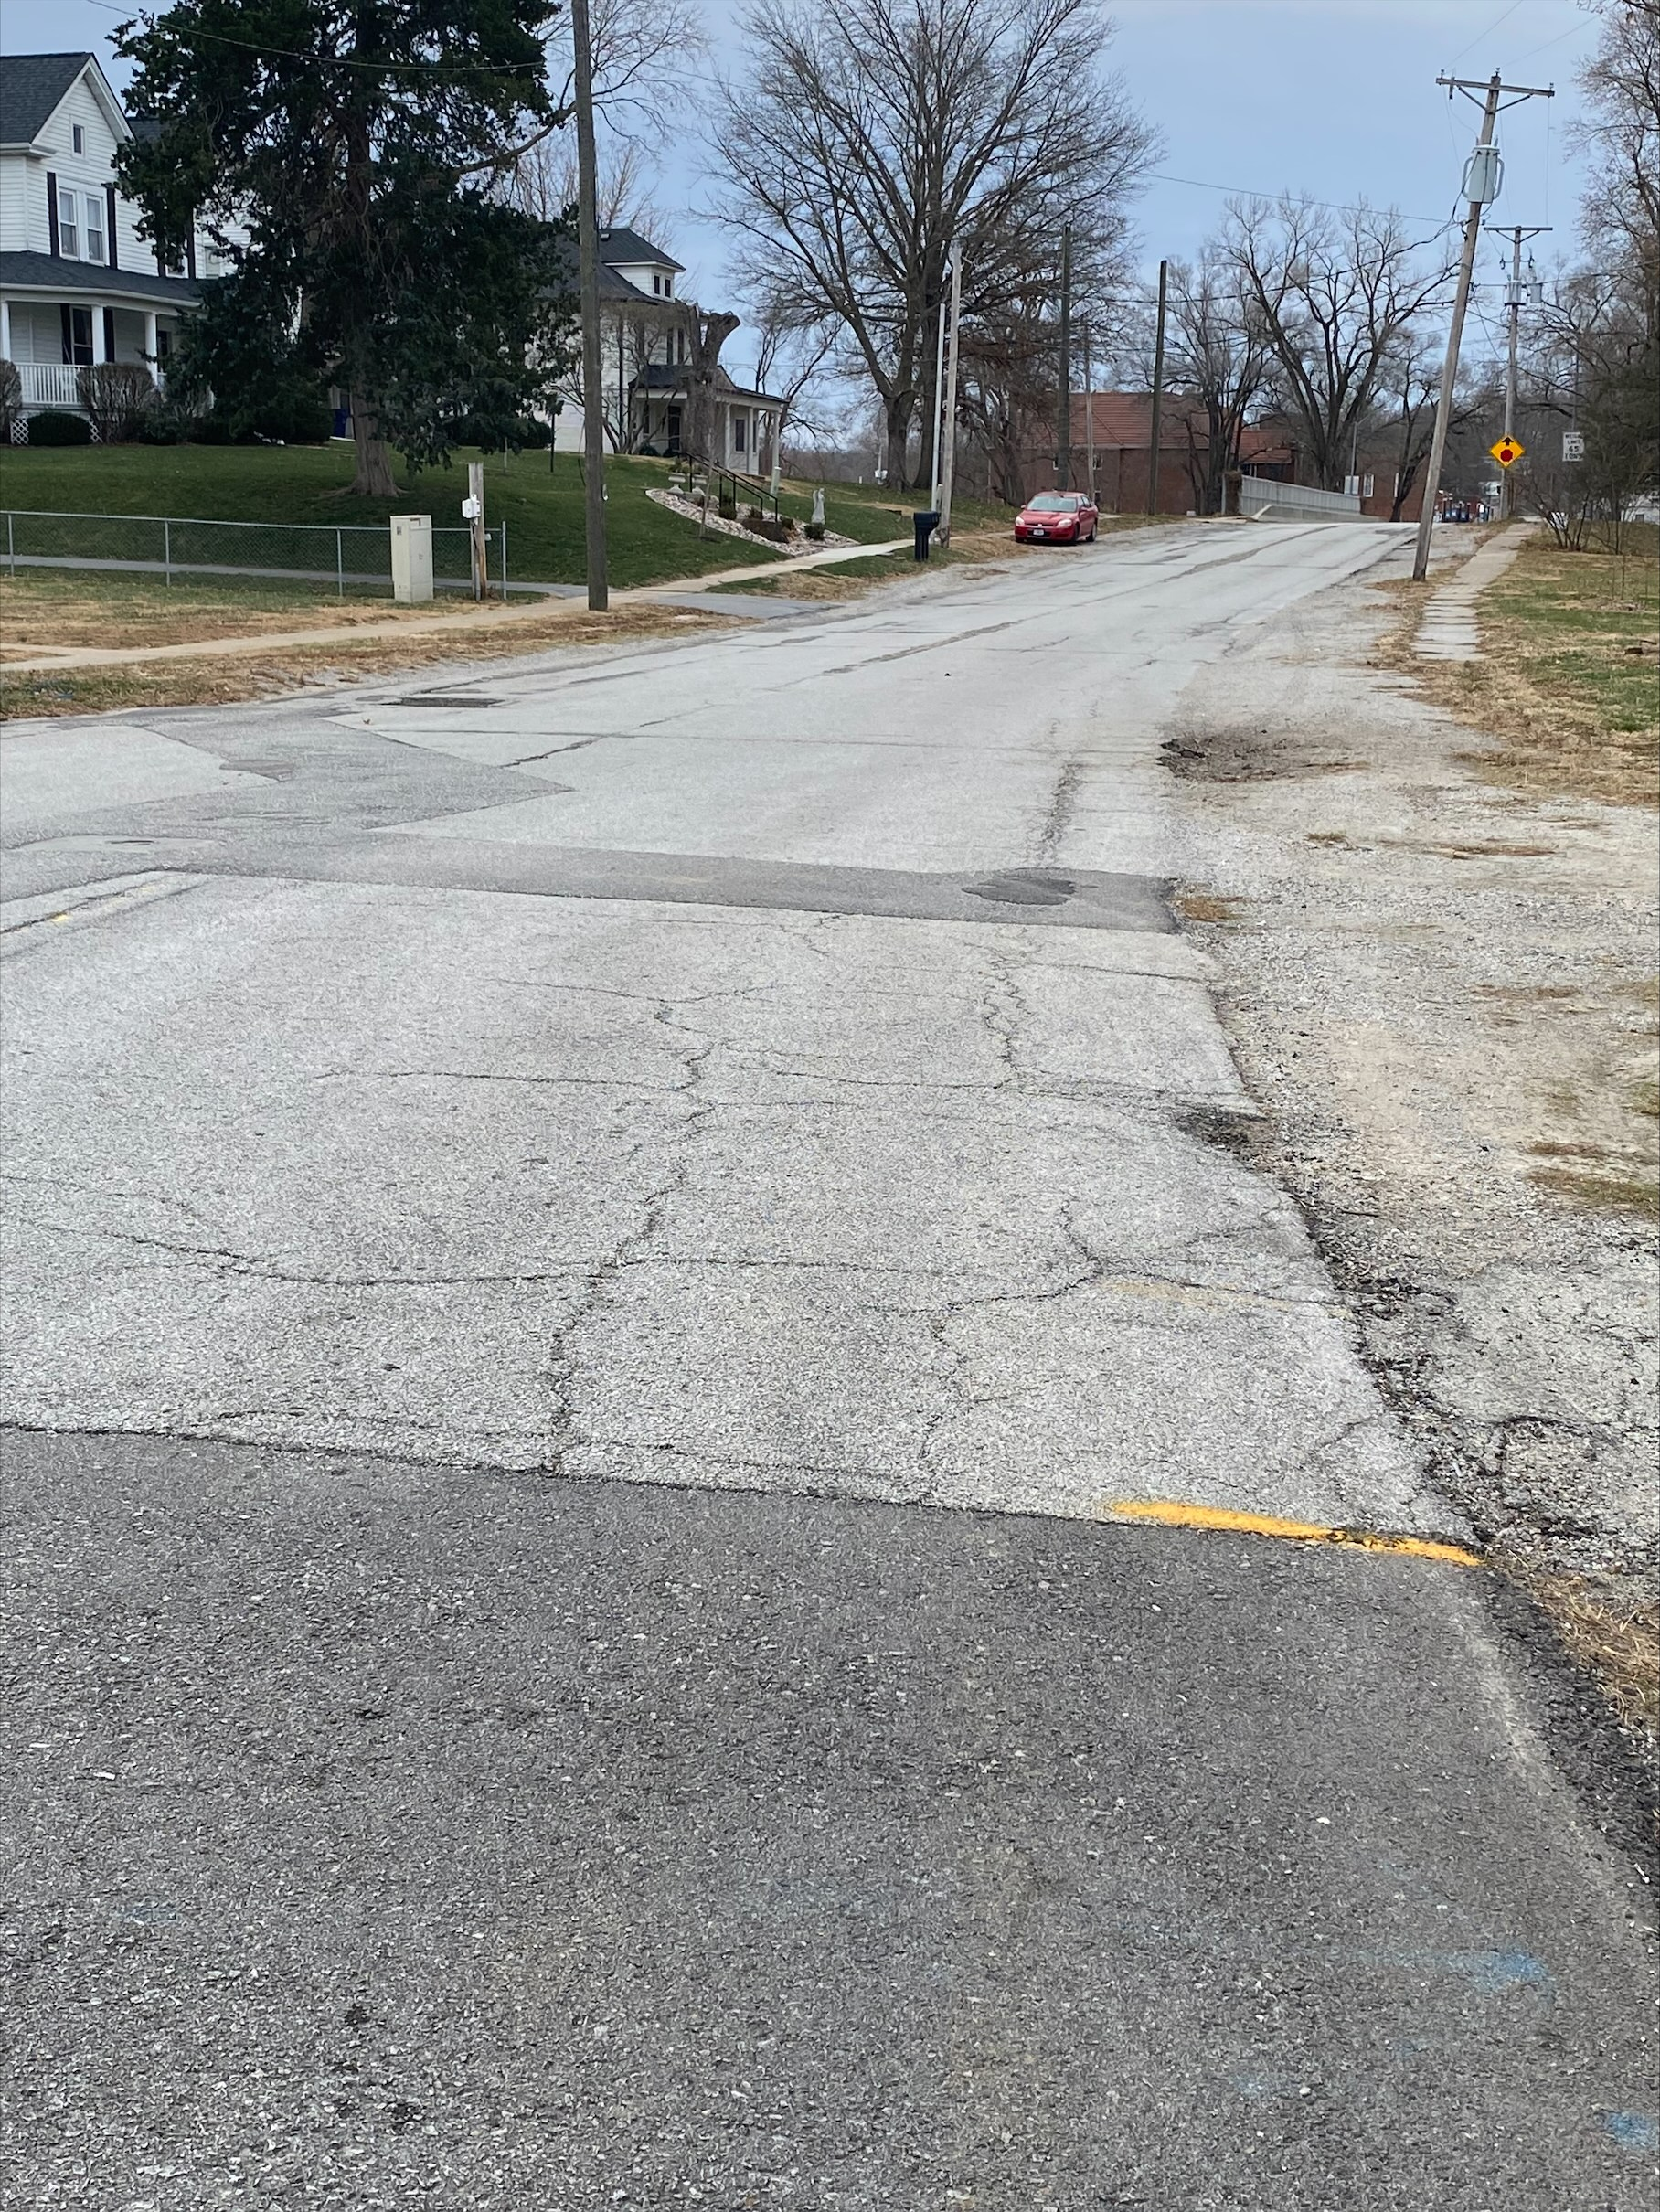

**Impact on Operating Costs:**

The project plans include decorative street lighting. The City is responsible for the maintenance on these lights, resulting in future operational costs. The new mill and overlay will reduce the amount of road repairs in the future in this area.

**Planned Expenditures**

|  |  |  |  |
| --- | --- | --- | --- |
| **Phase** | **FY 2024** | **FY 2025** | **Project Total** |
| **Engineering** | **$97,000** | **-** | **$97,000** |
| **Construction** | **-** | **$800,000** | **$800,000** |
| **Total** | **$97,000** | **$800,000** | **$897,000** |

**Funding Sources**

|  |  |  |  |
| --- | --- | --- | --- |
| **Source** | **FY 2024** | **FY 2025** | **Project Total** |
| **Capital Improvement Sales Tax** | **$97,000** | **$312,000** | **$409,000** |
| **TAP Funding (MoDOT)** | **-** | **$1,488,000** | **$1,488,000** |
| **Total** | **$97,000** | **$1,800,000** | **$1,897,000** |

**Updated** : August 16, 2024